xpedx.com Next Generation
Technical Design Specification – Product Detail

Authors: | Sterling Commerce
Version: | 0.2
Date Created: | 28/05/2010
Last Updated:

Document Revision History
Revision | Date | Description | Author
0.1 | 28/05/2010 | Draft | Sterling Commerce

Document Approval History
Name | Signature | Date | Version Approved/Comments

Reference Documents
Document Name | Description | Owner | Location
SCI_Xpedx Solution Definition Document v1.0 | Solution Definition document | Sterling Commerce

Table of Contents
2.2.1 Design for XPEDXItemDetailsAction 3
2.3.3 UI Validations 3
2.3.4 Input Document 3
2.3.5 Output Document 3
2.3.6 Configuration 3
2.2.1 Design for XPEDXAddToCartAction 3
2.3.2 UI Design 3
2.3.3 UI Validations 3
2.3.4 Input Document 3
2.3.5 Output Document 3
2.2.1 Design for XPEDXDraftOrderModifyLineItemsAction 3
2.3.3 UI Validations 3
2.3.4 Input Document 3
2.3.5 Output Document 3
2.3.6 Configuration 3
3. Database Extensions 3
4. Exception and Error Handling 3
5. Security Aspects 3
5.1 Ownership 3
5.2 Encryption 3
5.3 Audit Trail 3
5.4 Other Security Aspects 3
6. Dependencies 3
7. Unit Test Cases 3

1. Introduction
This document describes the detail design for the Product Detail customization for xpedx. It covers the customization for Customer part number, UOM integration, Price and Availability intergration, Add to cart and Order multiple check.

Purpose
Provide the struts xml configurations and class level details for cart funcationality customization.

1.2 Nomenclature

Term | Description

2. Technical Components
XpedxCatalogStruts.xml

<struts>
<package name="xpedx.catalogFragment" namespace='/catalog' extends="catalogFragment">

<action name="itemDetails" class="com.sterlingcommerce.xpedx.webchannel.catalog.XPEDXItemDetailsAction">
<param name="mashups">xpedxItemDetails</param>
<param name="resourceId">/swc/catalog/catalogBrowsing</param>
<param name="xmlBindingFile">com/sterlingcommerce/xpedx/webchannel/catalog/XPEDXItemDetailsBinding.xml</param>
<param name="numOfItemsPerPromotion">2</param>
<param name="validationClass">com.sterlingcommerce.webchannel.catalog.ItemDetailsValidation</param>
<result name="success">/xpedx/jsp/catalog/XPEDXItemDetails.jsp</result>
<result name="goToPrintPage">/swc/jsp/catalog/printItem.jsp</result>
</action>

</package>

</struts>

2.1 Components Overview

2.2 Component Design

- XPEDXDraftOrderDetailsAction

2.2.1 Design for XPEDXItemDetailsAction
The class extends the ItemDetailsAction and implements the logic to fetch the customer details, item UOMs, Price and Availability for the requested UOM and Customer Part Number.

2.3.2 UI Design
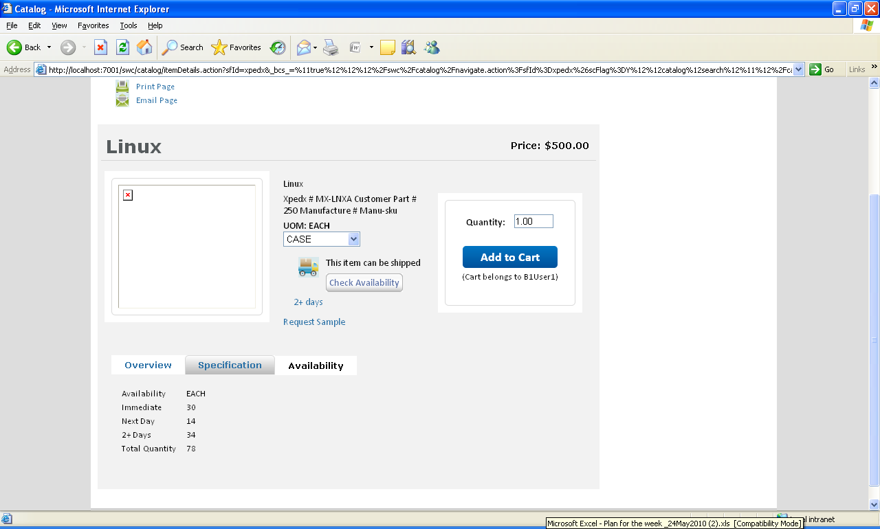

2.3.3 UI Validations
The quantity field is validated against the order multiple for that item and customer.

2.3.4 Input Document
<Input>
<XPXItemcustXref LegacyItemNumber="" CustomerBranch="" CustomerNumber="" CompanyCode="" EnvironmentCode=""/>
</Input>
2.3.5 Output Document

<XPXItemcustXref/>

2.3.6 Configuration

2.2.1 Design for XPEDXAddToCartAction
The class extends the OOTB AddToCartAction class, to implement item validation without considering the UOM. The class after validation adds the item to the cart with storing the requested UOM in the TransactionalUOM attribute of OrderLineTranQuantity element at orderline level and the quantity is stored in the OrderedQty attribute of OrderLineTranQuantity element.

2.3.2 UI Design
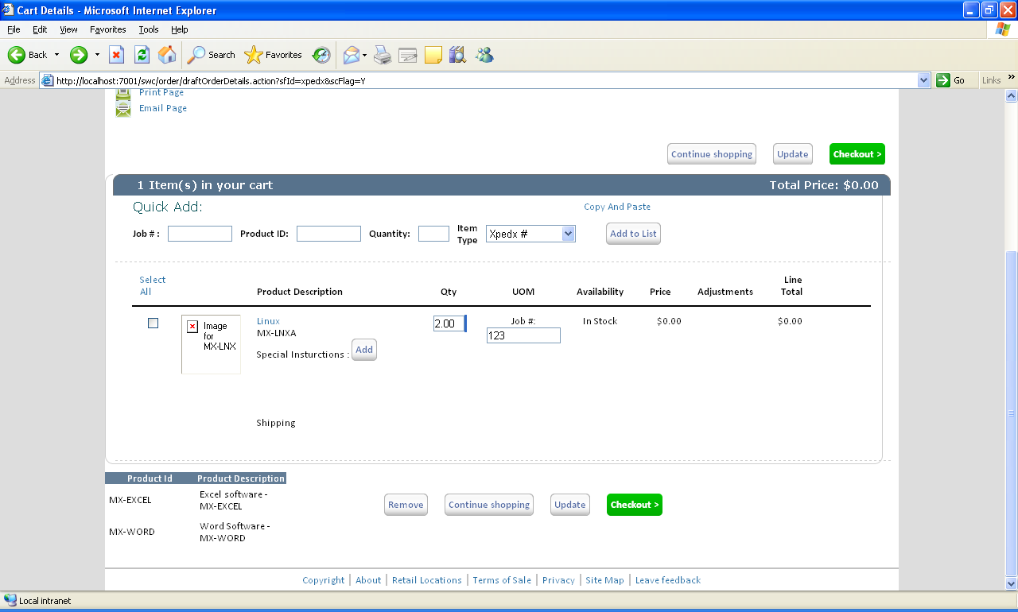

2.3.3 UI Validations
No UI Validations

2.3.4 Input Document
<Input>
<Order OrderHeaderKey="">
<OrderLines>
<OrderLine Action="CREATE" OrderedQty="" ReservationMandatory="N" ValidateItem="N">
<Item ItemID="" UnitOfMeasure="" ProductClass=""/>
<Extn ExtnJobID=""></Extn>
</OrderLine>
</OrderLines>
</Order>
</Input>
2.3.5 Output Document

<Order OrderHeaderKey="">
<OrderLines>
<OrderLine>
<Extn/>
</OrderLine>
</OrderLines>
</Order>

2.2.1 Design for XPEDXDraftOrderModifyLineItemsAction
Add a new method updateNotes(). This method is used to add special instructions at the order line level, edit and save the existing special instructions.
The mashup and binding are also changed to update job id at the line level.

2.3.2 UI Design
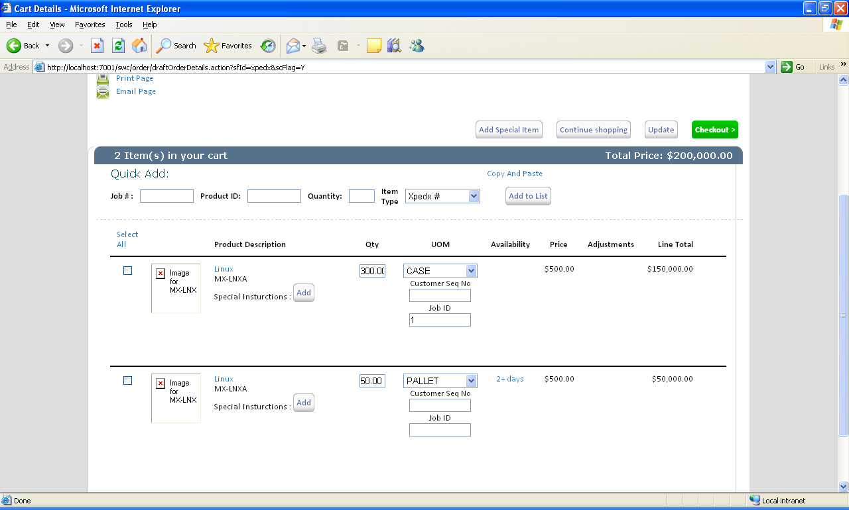

2.3.3 UI Validations
No UI Validations

2.3.4 Input Document
<Order OrderHeaderKey="">
<OrderLines><OrderLine Action="CREATE" OrderedQty="" ReservationMandatory="N" ValidateItem="N">
<Item ItemID="" UnitOfMeasure="" ProductClass=""/>
<OrderLineTranQuantity TransactionalUOM="" OrderedQty=""/>
</OrderLine>
</OrderLines>
</Order>

2.3.5 Output Document

<Order OrderHeaderKey=""/>

2.3.6 Configuration

3. Database Extensions
Table Name
Overview
Extensions/Custom/Hang-off
Primary Keys
Index on
Attribute Name | Column Name | Data Type/Size | OOB Data Type Name | Default Value | Description

4. Exception and Error Handling

5. Security Aspects
5.1 Ownership
5.2 Encryption
5.3 Audit Trail
5.4 Other Security Aspects

6. Dependencies

JIRA no | desc | To be validated by  (Team/Person) | Status | Implications if incorrect
1 | PandA service | Pawan |  | Not show the proper availability details
2 | ItemUOM utility method | Manohar |  | List of UOM will not be shown.
3 | OrderMultiple utility method | Manohar |  | Order Multiple Check and Add to cart will not work as expected.

No. | Assumption | To be validated by  (Team/Person) | Status | Implications if incorrect

7. Unit Test Cases
Test No. | Test Description | Execution Instructions | Expected Result
1 | Xpedx#,Manuf#, Customer# | Go to Product detail page | Should show Xpedx#,Manuf#, Customer# for that item.
2 | Product UOM | Go to Product detail page | Should display a list of UOMs with the default UOM calculated properly.
3 | Request Sample | Go to Product detail page | Request sample should be displayed if the corresponding flag is set for that customer.
4 | Availability | Go to Product detail page | The product availability details for immediate, next day and 2+ days should be displayed for default UOM.
5 | Change RequestUOM | Select a different UOM from the dropdown. | The page should display the new availability details of the product for this UOM.
6 | Order Multiple Check | Select a UOM and enter Quantity and click Add to Cart. | The total base qty for the base UOM obtained by multiplying the entered Qty with conversion factor of the selected UOM must be a multiple of OrderMultiple set for this product and customer.
7 | Add item to cart | Click Add to Cart. | This product should be added to the current active cart with the selected UOM and Qty.

